6SENG002W Concurrent Programming

FSP Process Analysis & Design Form

Name | Tharindu De Silva
Student ID | W1761890/2018367
Date | January 2023

1. FSP Process Attributes

Attribute | Value
Name | PRINTER
Description | This is a model of a printer, and its behaviour is based on printing documents. Printer will consume papers while printing documents and its need to be refilled with paper.
Alphabet | alphabet(PRINTER) = {acquirePrint, acquireRefill, print, refill, release}
Number of States | 12
Deadlocks (yes/no) | No
Deadlock Trace(s)  (if applicable) | Not applicable

2. FSP Process Code

FSP Process:
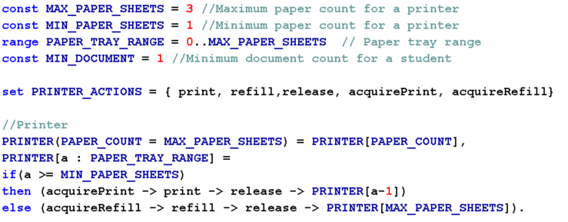

3. Actions Description
A description of what each of the FSP process' actions represents, i.e. is modelling. In addition, indicate if the action is intended to be synchronised (shared) with another process or asynchronous (not shared). (Add rows as necessary.)

Actions | Represents | Synchronous or Asynchronous
acquirePrint | Acquiring the lock on the printer for mutual exclusive access to print a document. | Synchronous
acquireRefill | Acquiring the lock on the printer for mutual exclusive access to refill the paper. | Synchronous
print | Print a document | Synchronous
refill | Refilling the printer with papers | Synchronous
release | Releasing the printer after the document are printed or completing the refilling paper process. | Synchronous

4. FSM/LTS Diagrams of FSP Process
Note that if there are too many states, more than 64, then the LTSA tool will not be able to draw the diagram. In this case draw small diagrams of the most important parts of the complete diagram.

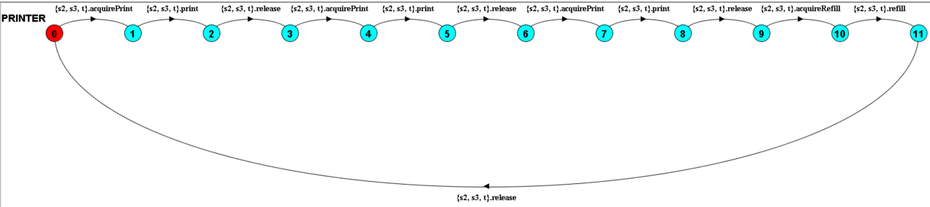

5. LTS States
A description of what each of the FSP process' states represents, i.e. is modelling. If there are a large number of states then you can group similar states together &/or only include the most important ones. For example, identify any states related to mutual exclusion (ME) & the associated critical section (CS), e.g. waiting to enter the CS state, in the CS state(s), left the CS state. (Add rows as necessary.)

State | Represents
Q0 | The printer containing 3 paper sheets and ready to be used. Waiting to enter the CS state.
Q1 | The printer is acquired by a process for printing the first document. ME
Q2 | The printer has printed the first document and ready to be released. Left the CS state.
Q3 | After printing the first sheet, the printer has been released and at this state printer has 2 remaining sheets ready to print. Waiting to enter the CS state.
Q4 | The printer is acquired by a process for printing the second document. ME
Q5 | The printer has printed the second document and ready to be released. Left the CS state.
Q6 | After printing the second sheet, the printer has been released and at this state printer has 1 remaining sheet ready to print. Waiting to enter the CS state.
Q7 | The printer is acquired by a process for printing the third document. ME
Q8 | The printer has printed the third document and ready to be released. Left the CS state.
Q9 | After printing the last sheet, the printer has been released and at this state printer has 0 sheets remaining and is ready to be refilled. Waiting to enter the CS state
Q10 | The printer has been acquired for refilling.
Q11 | The printer is waiting to be released, at this state printer has 3 sheets of paper.

6. Trace Tree for FSP Process
The trace tree for the process. Use the conventions given in the lecture notes and add explanatory notes if necessary.

